July 27, 2026

To: | Cultural Arts Commission
from: | Ata Khan, Deputy Director of OEBA  Jocelyn Ayala, AIPP Program Manager
subject: | Mural Permit (MURAL-000257-2026) - 395 S. Thomas St.
Staff Recommendation: | Approval of the mural permit for 395 S. Thomas St. (MURAL-000257-2026)

PROJECT INFORMATION

Address | 395 S. Thomas St.
Assessor’s Parcel Number (APN) | 8341-005-011
General Plan Designation | Transit Oriented District: Core
Zone | Downtown Pomona Specific Plan (DTSP-H)
City Council District | District 2
Applicant | John Peña
Submission Date | 7/01/2026

PROJECT DESCRIPTION

Applicant, who is also the property owner, has proposed a mural on the north, west, and south facing fencing on the back lot of 395 S. Thomas St. All sides interact with public right of way.

The image below reflects the intended location of where the mural will be outlined in red. Part of the mural will be directly across from the School of Art & Enterprise that features the mural Pomonacopia by Andre Miripolsky.
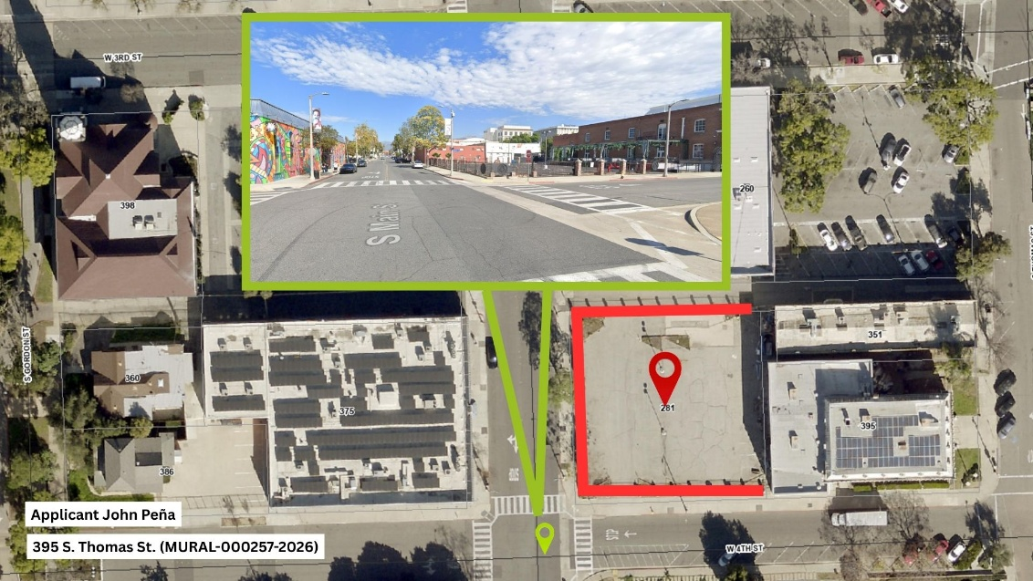

The mural will be placed on panels that also act as a privacy screen for the lot that will be utilized for private events. The size of the proposed mural is approximately 2,000 sq/ft. This mural would be painted directly onto recycled metal material that is attached to the existing fencing. The Applicant will ensure that all panels are cut to size to fit around the pillars between the fencing, as the panels are intended to be 8ft tall.

The below reflect renderings created by Staff to support visualization of the Applicant’s desired panel placement.

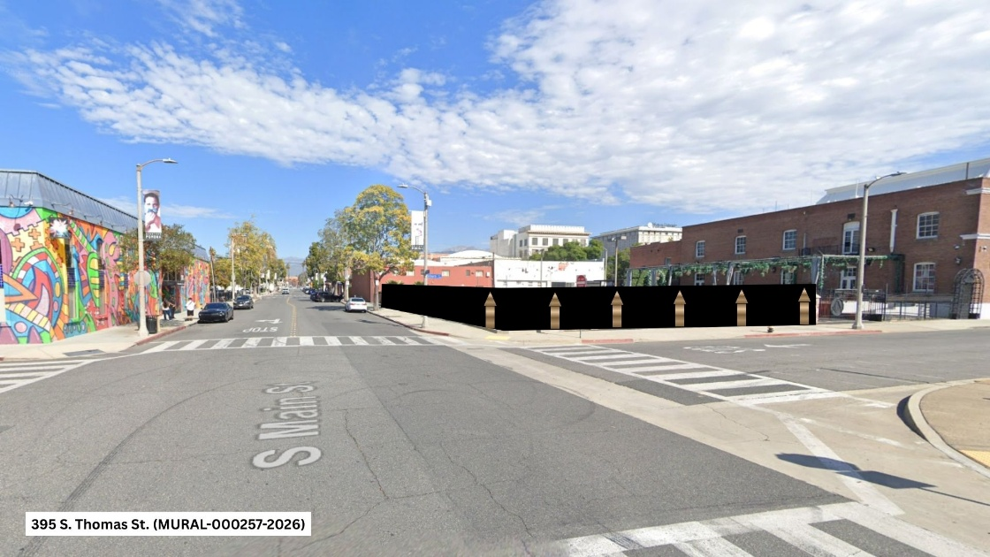

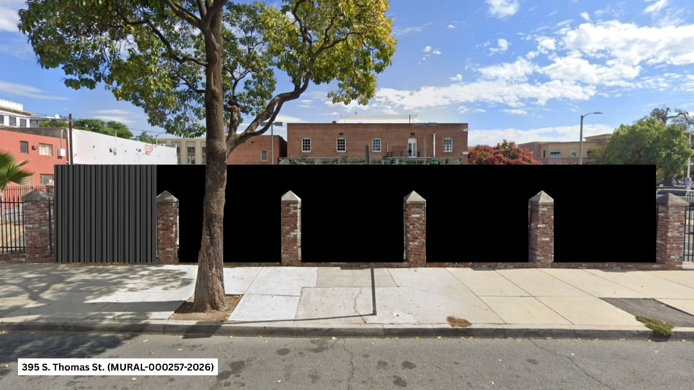

ARTIST & RENDERING OF ARTWORK

The Applicant will be working with the Artist Joe Ded.
Joe Ded is an artist who has worked with the City of Pomona in the past and has several murals in the community. Below are the renderings shared of the Artists work per the Applicant.

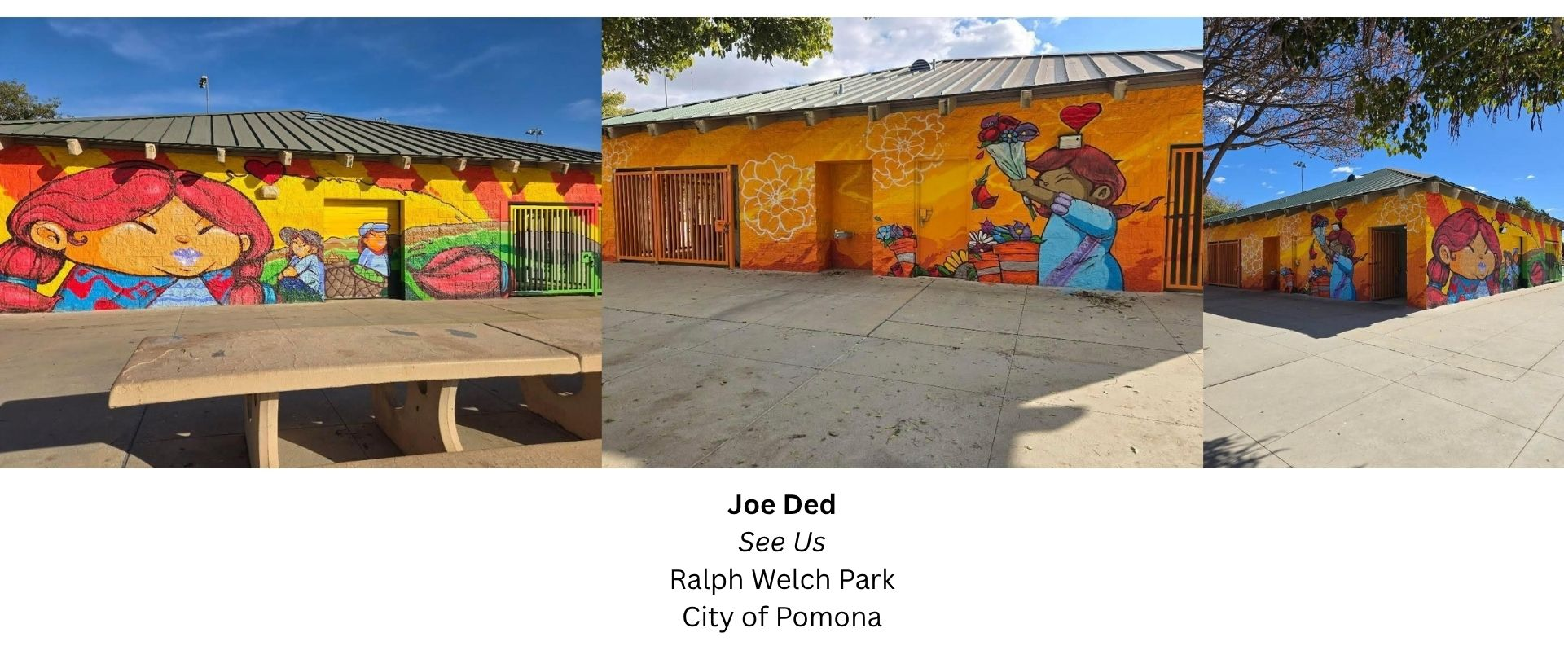

The Applicant did not submit the full rendering of the design but stated that the color palette and floral will remain consistent and continuous across the mural. Staff created the below images to support visualization of the application of the mural.

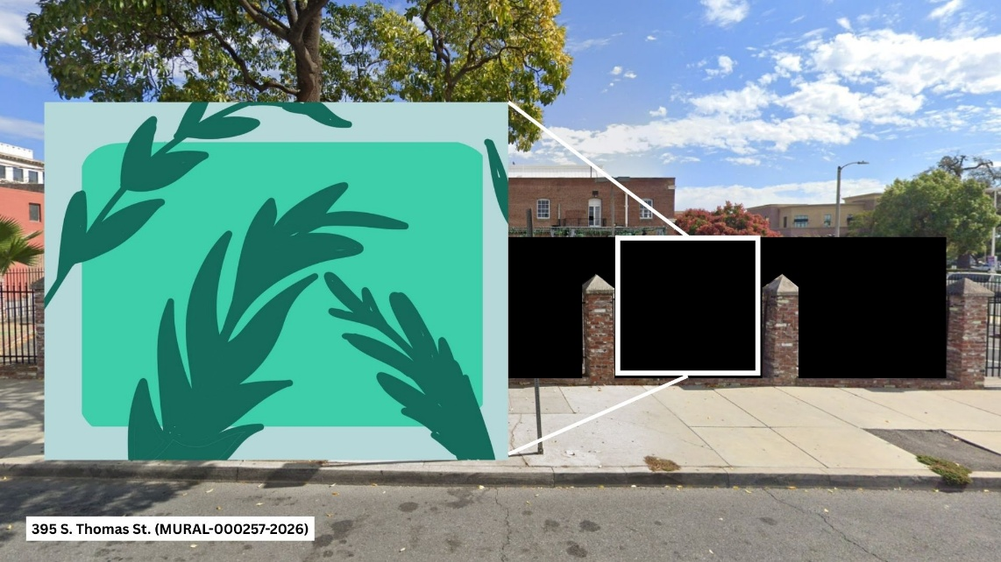

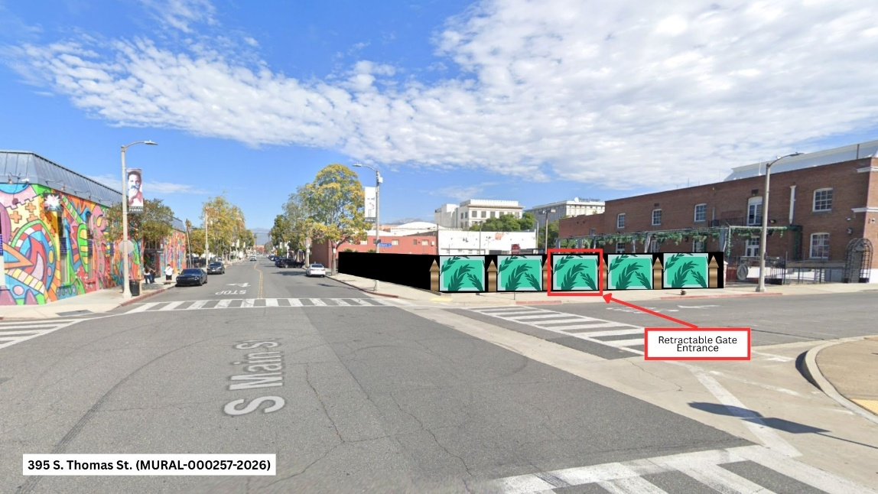

Artwork Information per application: Mural attached to the surface of panels, 94 Montana Spray paint, Mural sealant

AD-HOC COMMITTEE REVIEW
Below is a summary of the main points of the meeting.

On July 22, 2027, Committee approved unanimously of the artwork. Committee agreed on the positive aesthetic the mural will add to downtown and were supportive of Joe Ded as the artist. The only note had was in terms of possibly adding small pops of color through florals.

APPLICABLE CODE SECTIONS

Per Ordinance No. 4151, Section .5809-25(G), original artwork murals shall comply with the following:

- The Original Artwork Mural must demonstrate the highest aesthetic qualities originality and artistic excellence.
- The Original Artwork Mural is appropriate in scale, material, form, content and value with the immediate social and physical environment.
- The mural shall be durable, permanent, and easily protected from vandalism and weathering. Substantial consideration shall be given to the structural and surface integrity and stability of the building façade, the permanence and durability of the mural, and the mural’s resistance against weathering, theft, and vandalism.
- The mural shall not have any unsafe features or conditions that may affect public safety; and
- The mural shall not disrupt traffic, nor create any unsafe conditions or distractions to motorists and pedestrians.
- The artist is capable of completing the work in accordance with the plans and specifications.
- The information contained in the application regarding the durability and maintenance requirements of the mural is accurate.
- The proposed materials to be used and the manner of application will not require excessive maintenance and repair costs by the owner.

Attachments:

- Mural Permit Application
- Draft CAC Resolution No. ### (MURAL-000257-2026)
- Public Hearing Notice

