July 27, 2026

To: | Cultural Arts Commission
from: | Ata Khan, Deputy Director of OEBA  Jocelyn Ayala, AIPP Program Manager  Alina Barron, Senior Planner
subject: | Final Design Plan (PUBART-000122-2026) – 501 E. Mission Blvd.
Staff Recommendation: | Approve of Final Design Plan for 501 E. Mission Blvd. (PUBART-000122-2026).

PROJECT INFORMATION

Address | 501 E. Mission Blvd.
Assessor’s Parcel Number (APN) | 8335-014-054
General Plan Designation | Transit Oriented District: Neighborhood
City Council District | District 2
Applicant | Andrea Galvan, KMA Construction
Property Owner | National Community Renaissance (National CORE)
Related Entitlements | DPR-15833-2021
Submission Date | 04/01/2026

PROJECT SUMMARY

The proposed project will place artwork at the site of a proposed development to satisfy the requirements of the Art in Public Places (AIPP) Program. The subject site is in active construction for development of a single 4-story 75-unit residential structure and has a tentative completion date of Winter 2026. The applicant is proposing four pieces of public art by three artists to be placed on-site.

PREVIOUS ACTION

7-06-2026 | Applicant submitted new rendering for the mural section, and all committee members approved of this new rendering.
6-15-2026 | Cultural Arts Commission reviewed and made the following recommendations to Cultural Arts Commission—Approval of the tactile sculpture and the painting of the hand chair, but denial of the murals current design and a request for a more culturally appropriate design.
6-03-2024 | Development Services Director granted request for time extension as outlined in DPR Resolution No. 22-001.
6-02-2022 | DPR Resolution No. 22-001, Zoning Administrator approval of Development Plan Review (DPR-15833-2021) for the development of a 4-story, 75-unit residential structure including 15 live/work groundfloor units.
12-08-2022 | PC Resolution No. 21-034 - Planning Commission approval of General Plan Conformity (GPC 17348-2021) for an alley vacation located between Palomares Street and Linden Street.
2-7-2022 | CC Resolution No. 2022-19 - City Council approval for the  vacation of a public alley located north of Mission Boulevard, between Linden Street and Palomares Street, Vacation No. V-318. Approved February 7, 2022.

AD-HOC COMMITTEE REVIEW
Below is a summary of the main points of the meeting.

On June 15, 2026, the Committee met to review and discuss the proposed final design plan. All three committee members were present (Heather Albertson, Elizabeth Redd, and Sarina Del La Torre) with Staff members Ayala and Barron present.

Staff walked committee members through the Final Design Plan by starting with information about the project in general and the artwork that was being proposed. Committee members had questions, fielded by Barron, regarding the agreed areas in which artwork could be proposed. Committee members suggested that the building being gray was too much for a mural with so much color, and the discussion of why the mural wasn’t covering more of the wall was also discussed. However, Committee was made aware these were changes that could not be made as the areas were already agreed upon.

For the tactile wood sculpture, Committee members asked about maintenance to which the Final Design Plan states—"The ball bearings may need to be replaced every 5+ years, and if the property owner so chooses the tactile component and frame can be resealed with polyurethane and enamel paint on the metal frame.” The Committee had no notes further for this sculpture and agreed to move it forward to Commission for review.

For the painting on the chair, Committee members asked about maintenance as it was not mentioned in the Final Design Plan and with it being usable they would want to see it maintained but agreed to move forward to Commission for review. Staff followed up with the Applicant that the chair would receive maintenance like the timeline of the tactile sculptures, so every 5+ years it would receive new coatings.

For the mural, Committee members were not in agreement, as they felt the mural lacked “cultural relevancy” to Pomona. They appreciated the colors but felt that a prominent area downtown deserved more of a narrative to share explicitly about the people of Pomona. The committee did not approve the proposed rendering. Staff relayed the sentiments of the committee to the Applicant, to which they wanted to propose another mural that was previously discussed and would be a better fit.

On July 6, 2026, the Applicant shared a new rendering, and Staff relayed to Committee members for any comments. All committee members said they would recommend this new rendering to Commission for review.

PROJECT DESCRIPTION
Further information can be found in the attachments.

Brief Summary of Housing Development
Prisma Artist Lofts – 501 E. Mission
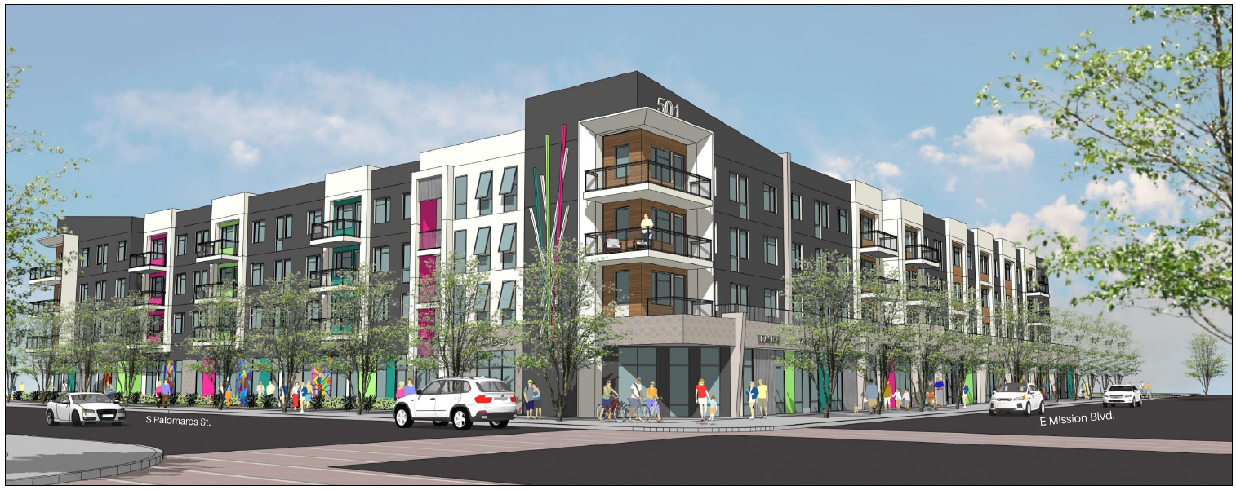
Rendering of Palomares St. & Mission Blvd. Intersection

The housing development is a single 4-story L-shaped structure, with 75 residential units including 15 ground floor live/work units. Each live/work unit contains a store-front glass door activating frontage along Palomares Street and Mission Boulevard and maximizing the ability of residents within the live/work units to operate a business. The intention is for these 15 ground floor units to be for artists. Additionally, the development will feature a 1,964 sf community room and 817 sf art space on the corner of E. Mission Blvd. and S. Palomares Street adjacent to the proposed mural.

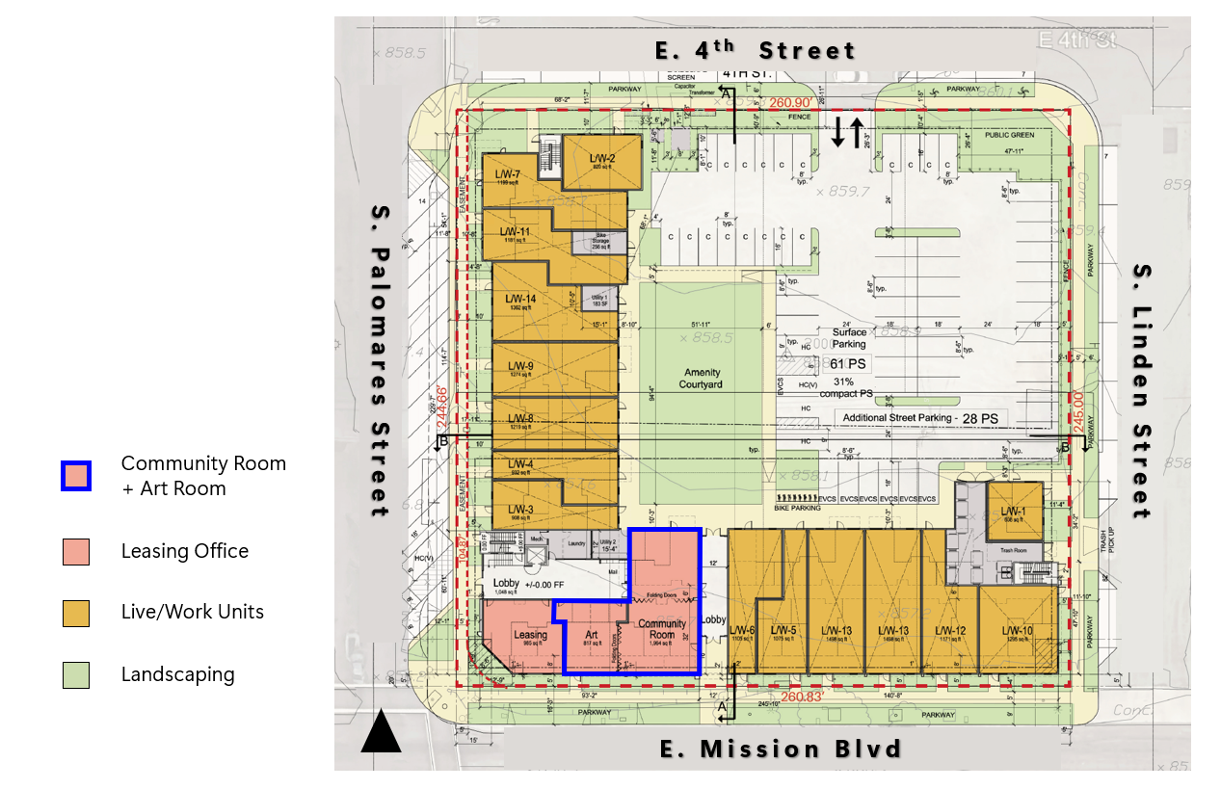
Ground Level Floor Plan – 501 E. Mission Blvd.

Location

The location is a single block of approximately 1.45 acres (outlined red) located along East Mission Boulevard, with frontages along South Palomares Street, Fourth Street, Linden Street and Mission Boulevard. It is located east of Garey Avenue and south of Third Street and lies southeast of the Downtown Pomona area.

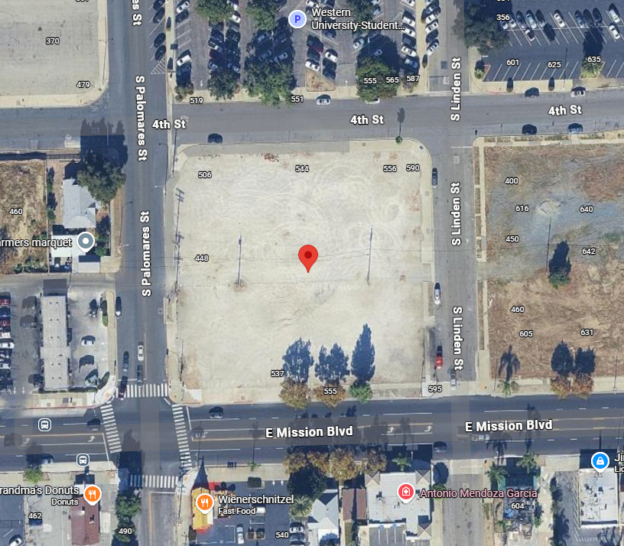

Art in Public Places

The proposed project qualifies as a contributing project under the City’s AIPP Ordinance, which requires the provision of onsite public art or the payment of an in-lieu contribution into the AIPP fund, each in the amount equal to one-percent (1%) of the building valuation for a project.

AIPP Fee: $133,837.83

A breakdown of costs associated with this valuation is presented in the Budget Form (Attachment 2).

PUBLIC ART DESIGN PLAN
Further information can be found in the attachments.

Artists

This project includes three artists—Jorge Moawad, Elizabeth Jones, and Oscar Magallanes. Each artist will take on a different part of the art installation for the site.

Jorge Moawad

George’s creativity with design and quality craftsmanship reimagines the woodworker. His carpentry work, whether cabinets or doors, authenticates any space. The furniture he creates promotes the high value of purpose. With sculpture, George is extra free to express his awe for material with artistic instincts and mathematic ideas. In all ways woodworking, George’s pursuit of mastery is one of a kind.

George has been handcrafting his art and enterprise for over ten years straight out of his home studio workshop in Pomona, California. The area’s art community, being surrounded by other artists pursuing their passions, has been an inspiring force in George’s journey and the source of many friendships. Just as meaningful to George, especially because of the singularity of his workshop and potential for dynamic collaborations, is his availability and service to the community.

Website: Luz de Mano

Elizabeth Jones

Elizabeth Jones is a painter and food systems activist with over a decade’s experience maintaining both artistic practice and involvement in grassroots food access work. While in Santa Cruz they worked with various farms and gardens as well as Food Systems Working Group, an organization dedicated to increasing the community’s access to quality nutritious food. The focus of Elizabeth’s artistic practice has shifted towards utilizing art to highlight community members’ experiences, values, and visions of a future in which we are all thriving. In addition to expanding their knowledge of land stewardship and community health, Elizabeth is applying their expertise to creating a collection of drawings, paintings, and stories about their community’s efforts to increase food sovereignty, heal psychological trauma, advocate for workers’ rights, regenerate the local microbiome, and work towards implementing a restorative justice system.

Website: elizabeth jones

Oscar Magallanes

Magallanes is a Los Angeles-based artist working with painting, sculpture, and mixed media. His artwork is informed by the cultural and social elements of his upbringing in a Mexican-American barrio east of downtown Los Angeles. At the age of fifteen, he was expelled from high school but was accepted into the Ryman Arts program at the Otis College campus, which encouraged him to become a professional artist. His work often touches down at the intersections of cultural iconography, the folkloric, and the aesthetics of propaganda.

Website: Oscar Magallanes

Proposed Artwork

Tactile Sculpture – Jorge Moawad

Artwork Title: | The Hands that Touch Pomona Spinner
Description: | Moawad’s sculpture will be a tactile piece that uses a plastic bonding mechanism and wood to create organic shapes visitors can touch and transform both immediately and over time. The piece will be in the pocket park and nods to the tic-tac-toe spinner play objects often found on children’s playgrounds. Moawad in his former life was a high school geometry teacher whose work also invites play from young and old alike while considering how we shape the world around us.  The selection of wood working as a central element of the hands that touch series pays homage to the Pomona Valley artist, Sam Maloof, and his broad support for regional artists. The wood components will be composite and made from wood reclaimed from household items from around Pomona.  The work reinforces the impact we have in our community as individuals and how we shape an ever-changing map of a community that changes much more slowly over time. The work is designed to be touched and over time to wear away with repeated touch.
Maintenance: | The ball bearings may need to be replaced every 5+ years, and if the property owner chooses the tactile component and frame can be resealed with polyurethane and enamel paint on the metal frame.
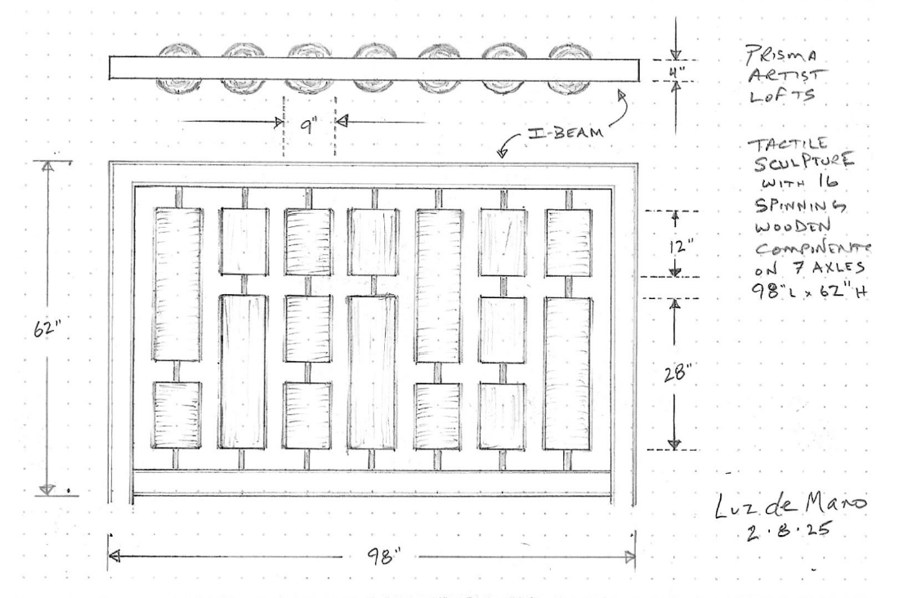

Functional Seating – Elizabeth Jones
Note: Funding is not being utilized to purchase the hand chair, as we do not permit prefabricated work to be bought for artwork. The funding is only paying for the painting of the chair.

Artwork Title: | The Hands that Feed Us
Description: | The hand chairs are functional objects selected to invite joy while resting in the pocket park. The chairs are the canvas for art that ties the theme together by reinforcing Pomona’s agricultural roots and the deep connections between Chicano art and culture and farm workers labor movements. Additionally including native plants and traditional staples in Mexican culture bring the three pieces of art together to tell a cohesive narrative about the role artist’s play in telling Pomona’s story.
Maintenance: | Not provided.
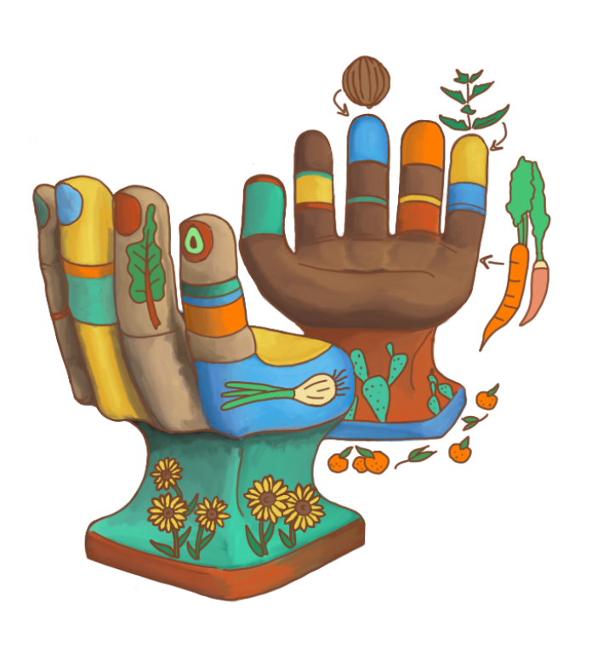
Main Mural – Oscar Magallanes

Artwork Title: | The Hands that Connect Pomona Mural
Description: | Magallanes’ mural connects murals across the Pomona Valley from the historic Mexican muralists housed at the Claremont Colleges to contemporary street art seen on auto garages to indigenous art referencing local ecologies. Prisms tie the project to the Southern California light and space movement and connect Pomona to the wider cultural map. Designs at the top of each pillar reference serapes and sunsets. Weaving together shared experiences that tie arts and local culture together. Magallanes explores themes present throughout his work including Mid-century modernism, Mexican muralism, and Pre-Columbian geometric forms.
Maintenance: | The mural’s height will dissuade potential vandals and materials selected allow for the building maintenance crews to retouch the sealant alongside regular building maintenance. This is not expected to incur additional costs beyond regular maintenance.

Original Proposed Rendering: | New Proposed Rendering:
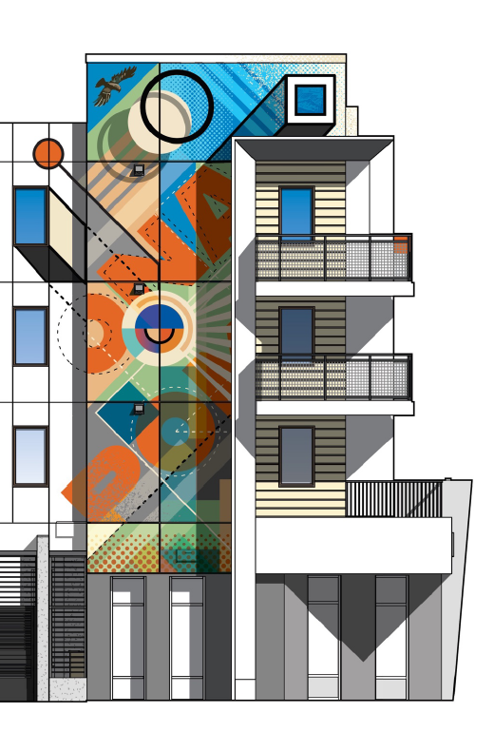 | 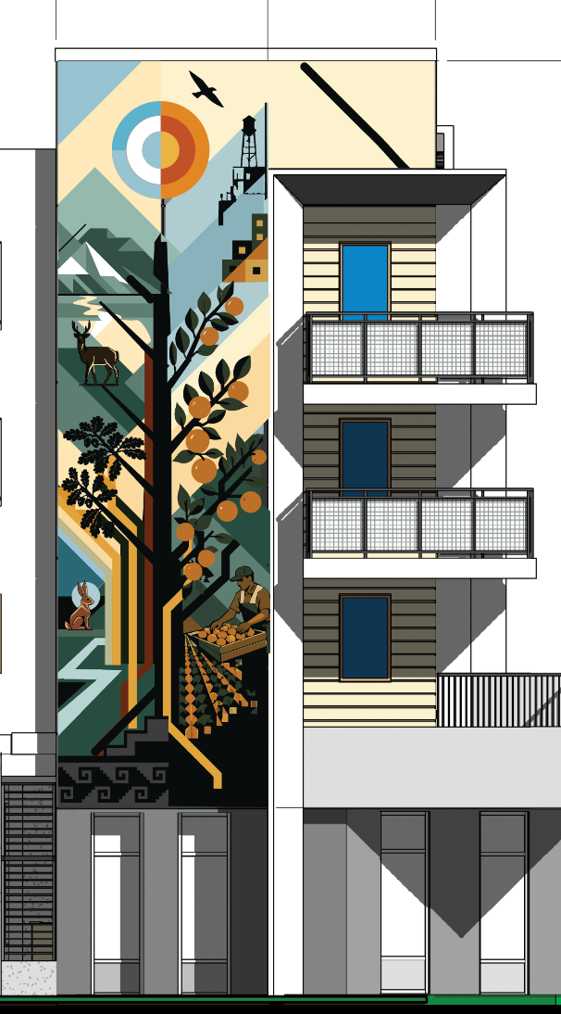

Attachments:

- Draft CAC Resolution No. ### (PUBART-000122-2026)
- Applicant Submission - Conceptual Design Plan
- Applicant Submission - Budget
- Public Hearing Notice

