
Planning Commission
Planning Division Staff Report

DATE: | January 22, 2025
TO: | Chairperson and Members of the Planning Commission
FROM: | Planning Division
SUBJECT: | Phase II of the Zoning Code Update: Minor Revisions

SUMMARY

On July 1, 2024, the City of Pomona adopted Ordinance No. 4345, approving a comprehensive update to the Pomona Zoning and Subdivision Ordinances. The new Zoning & Development Code successfully implements the goals and policies of the 2014 Pomona General Plan (“General Plan”) and meets the grant objectives set by the California Department of Housing and Community Development in its SB 2 and LEAP programs for permit streamlining to accelerate housing production.

Planning Division staff has now been utilizing the new Zoning & Development for approximately six months and have identified key issues pertaining to Section 11100.J. Frontage Exceptions.

COMMISSION FEEDBACK

Staff will summarize current issues with Frontage exceptions and will facilitate a discussion to begin exploring how the City may approach resolutions to issues found within the new Zoning & Development Code Nonconformities – Frontage Exceptions.

TIMELINE

Phase I (Complete): Updated Zoning & Development Code establishing
- new zoning framework implementing the General Plan place types, land use goals and policies through Zoning Districts, each with form, frontage, use modules, and site standards;
- objective design standards consistent with State Law;
- improved legal and procedural use of the code in a refined Administrative Chapter.

Phase II (In Progress): Updated Signs & Landscaping + Minor Revisions
- New sign regulations within Site standards and removal of the previous sign regulations
- Minor revisions to the new Zoning & Development Code (Nonconformities – Frontage Exceptions Section)
- New landscaping regulations within Site standards consistent with State Law
- Minor revisions to the new Zoning & Development Code (All Other Sections)

All revisions including Sign and Landscape regulations are proposed to come forth as separate amendments February – April 2025.

Prepared by: | Submitted by:
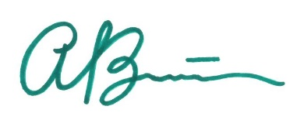 | 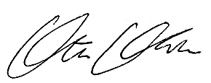
Alina Barron | Ata ul Malik Khan
Senior Planner | Deputy Director of Development Services

