
Planning Commission
Planning Division Staff Report

DATE: | January 22, 2025
TO: | Chairperson and Members of the Planning Commission
FROM: | Planning Division
SUBJECT: | Zoning Code Amendment (CODE-001403-2024)  Request to amend the Pomona Zoning & Development Code to remove Section .1310. “Signs” and incorporate new sign regulations in Pomona Zoning and Development Code Section 630. “Signs”.

EXECUTIVE SUMMARY

Staff is requesting that the Planning Commission continue this item to the Planning Commission meeting of February 12, 2025 to allow staff time to incorporate comments received from the City Attorney’s office on the draft sign code.

Prepared by: | Submitted by:
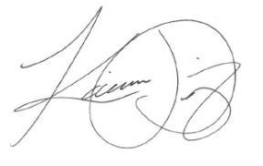 | 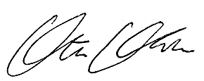
Karina Diaz | Ata ul Malik Khan
Assistant Planner | Deputy Director of Development Services
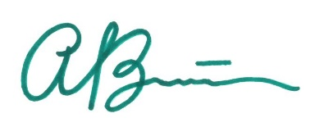
Alina Barron
Senior Planner

