
Planning Commission
Planning Division Staff Report

DATE: January 22, 2024

TO: Chairperson and Members of the Planning Commission

FROM: Planning Division

REQUEST: Time Extension (EXT 001781-2024)
Request for a time extension of Development Plan Review (DPR-18140-2022) and its associated Tentative Tract Map (TRACTMAP-18440-2022) for the development of an eleven unit condominium project on a property located at 312 W. Franklin Ave.

STAFF RECOMMENDATION

Staff recommends that the Planning Commission approve Time Extension (EXT 001781-2024) granting a one-year time extension for Development Plan Review (DPR-18140-2022) and a one-year time extension for Tentative Tract Map (TRACTMAP-18440-2022), subject to the conditions of approval listed in PC Resolution No. 22-032 and PC Resolution No. 22-033 (Attachment 2 & Attachment 3).

EXECUTIVE SUMMARY

The project applicant has submitted for an extension request (attachment 1) as permitted by PC Resolution No. 22-032 and PC Resolution No.22-033 for the development of an eleven unit condominium project and an associated tentative tract map on a 0.55 acre site addressed as 312 W. Franklin Ave (APN: 8344-021-055). PC Resolution No. 22-032 grants the development (DPR-18140-2022) a maximum of one, one-year extension request from the date the resolution is set to expire on December 14, 2024, whereas PC Resolution No. 22-033 grants the Tentative Tract Map (TRACTMAP-18440-2022) a maximum of one, one-year extension request from the date approving resolution is set to expire which is also listed as December 14, 2024.

The applicant has submitted time extension requests citing unexpected delays with the submittal of the project’s required plan check application, time needed to address administrative errors found in PC Resolution No. 22-033, and personnel changes both within City staff and the applicant’s development management team. Both entitlements under request for time extensions were approved on December 14, 2022 which were given a total of 24-months from the time of approval to complete the plan check process necessary to obtain buildings permits for the development.

If approved, the expiration date for Development Plan Review (DPR-18140-2022) will be extended from December 14, 2024 to December 14, 2025 and the Tentative Tract Map (TRACTMAP-18440-2022) from December 14, 2024 to December 14, 2025.

Property Details
Address | 312 W. Franklin Ave.
Assessor’s Parcel Number (APN) | 8344-021-005
Lot Size | 24,150 SF SF (0.55 AC)
General Plan Land Use Designation | Residential Neighborhood
Zoning District | RN1 [HM1-N1-R1]
Historic District | N/A
Specific Plan | N/A
City Council District | District 2
Applicant | Austin Dang, CDA+PDG, Inc.
Property Owner | Wei Chen

PROJECT STATUS AND TIMELINE

On December 14, 2022, the Planning Commission approved both Development Plan Review (DPR-18140-2022) and Tentative Tract Map (TRACTMAP-18440-2022) applications for the development of an eleven-unit condominium project located at 312 W. Franklin Ave.

On December 10, 2024, the Planning Division received an application (EXT 001781-2024) for time extensions for both DPR-18140-2022 and TRACTMAP-18440-2022, approved by the Planning Commission on December 14, 2022 by PC RESO #22-032 and PC RESO #22-033, respectively. The purpose for the time extension requests are to allow the applicant additional time to complete the Plan Check review process which have been prolonged in order to address significant administrative requirements and changes in both the applicant’s development management team and City staff.

Staff supports Time Extension (EXT 001781-2024) given the nature of the delays, the project’s compliance with goals and policies of the General plan at the time of Commission approval, and the applicant’s continued efforts to the achieve the development approved by PC RESO #22-032 / PC RESO #22-033. If approved, the expiration date for Development Plan Review (DPR-18140-2022) will be extended from December 14, 2024 to December 14, 2025 and the Tentative Tract Map (TRACTMAP-18440-2022) from December 14, 2024 to December 14, 2025.

Attachments

- Formal Letter of Request
- PC Resolution No. 22-032
- PC Resolution No. 22-033
- Approved Project Plans

Submitted by: Prepared by:

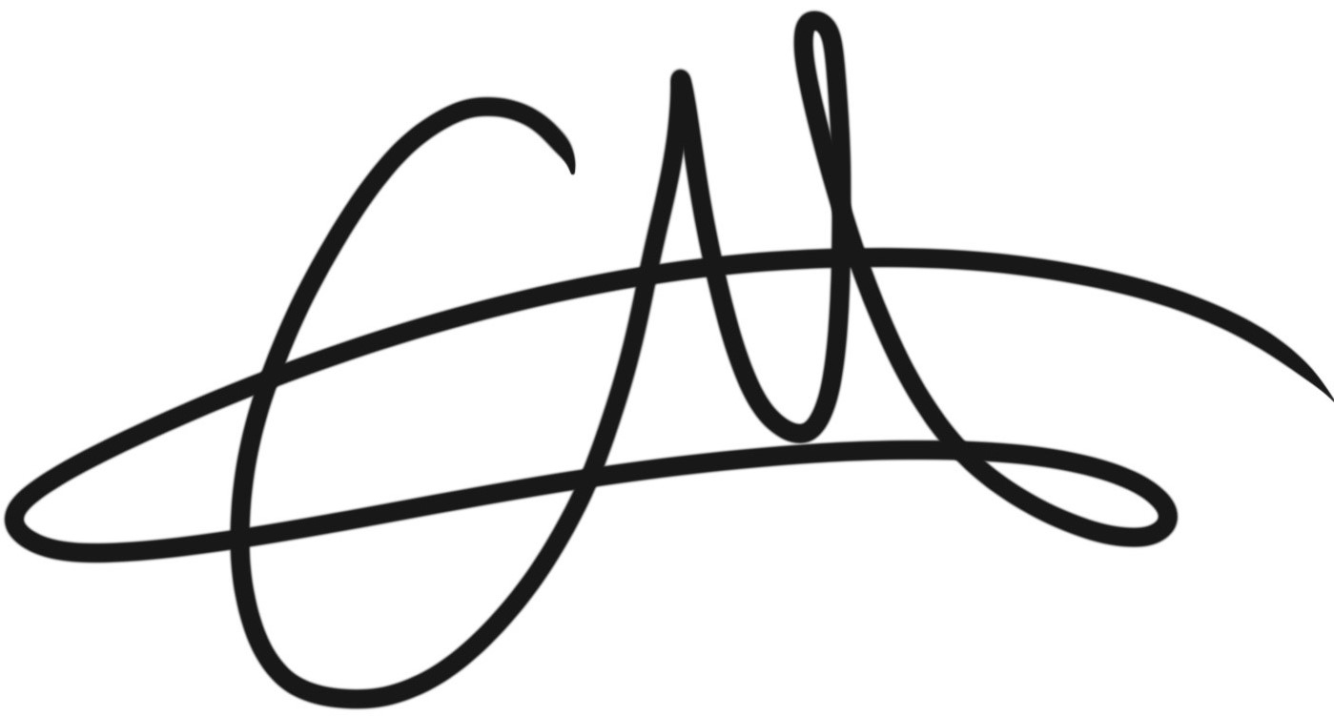
Geoffrey Starns, AICP, AIA, LEED AP Carlos Molina
Planning Manager Associate Planner

